Programming 512 Practical 2

Lecturer : Mr. N Mathenjwa

Question 1

* Open visual studio and create an application named Practical2.
* It will automatically create form1, change the name and text of form1 to Print Details in the properties window.
* Double click on the form to create a sub procedure named Print() which will take the inserted name by the user in a textbox reverse the name and display it in a message box.
* When the button “Print” is pressed the program should call the sub Print() to display the reversed name

Sub (Byval name As string)

‘do something here

End Sub

E.g. If the input is “Hello” the sub must print “olleH”

* The form must look like the below

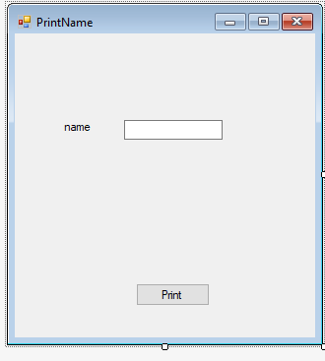

Question 2

* Add a list box and a button named display into the form created in Question 1
* When button “Display” is pressed the program must display the name in the listBox
* The form should look like the below form

